ECE 358 Chapter 2

2.1 Application Layer

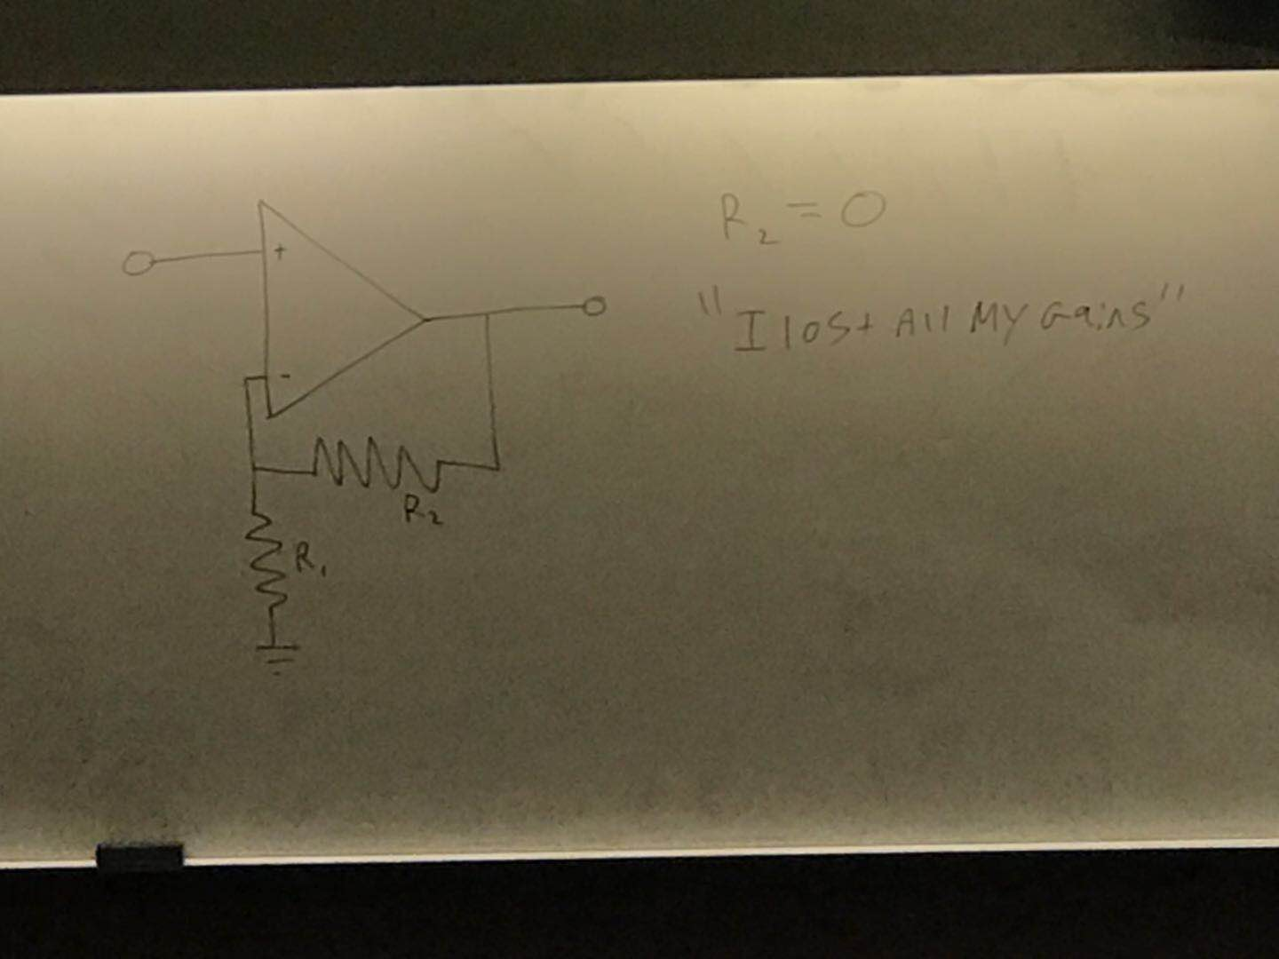

The layer of router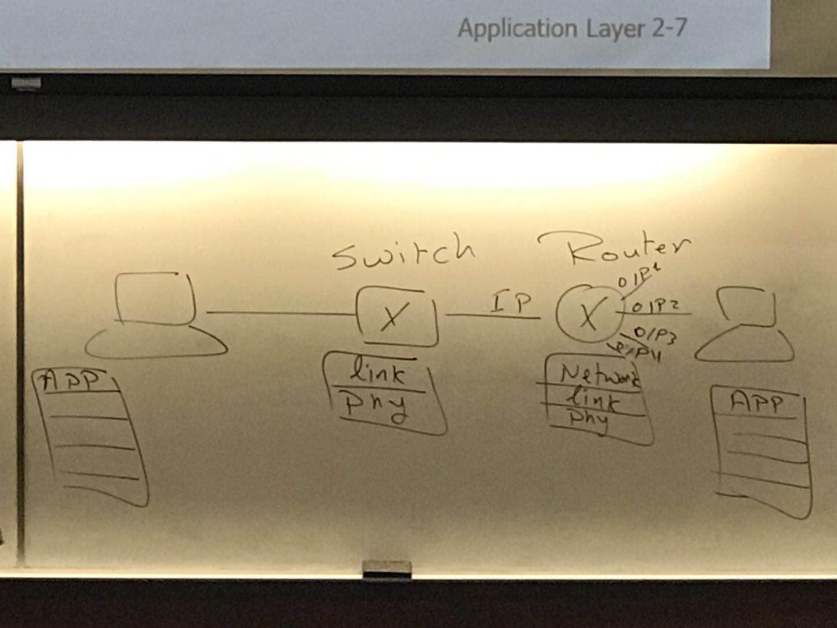

P2P architecture

There is no server, computer connect directly.

Challenges for P2P APP:

1. Incentives to encourage users to participate with their resources.
2. Challenging management (centralized)
3. Asymmetric bandwidth
4. Security is difficult to control

A socket will be used to differentiate between different processes running on the same network application in the same end system.

A socket is a combination of the IP address of the end system and a port number assigned by the end system to a process.

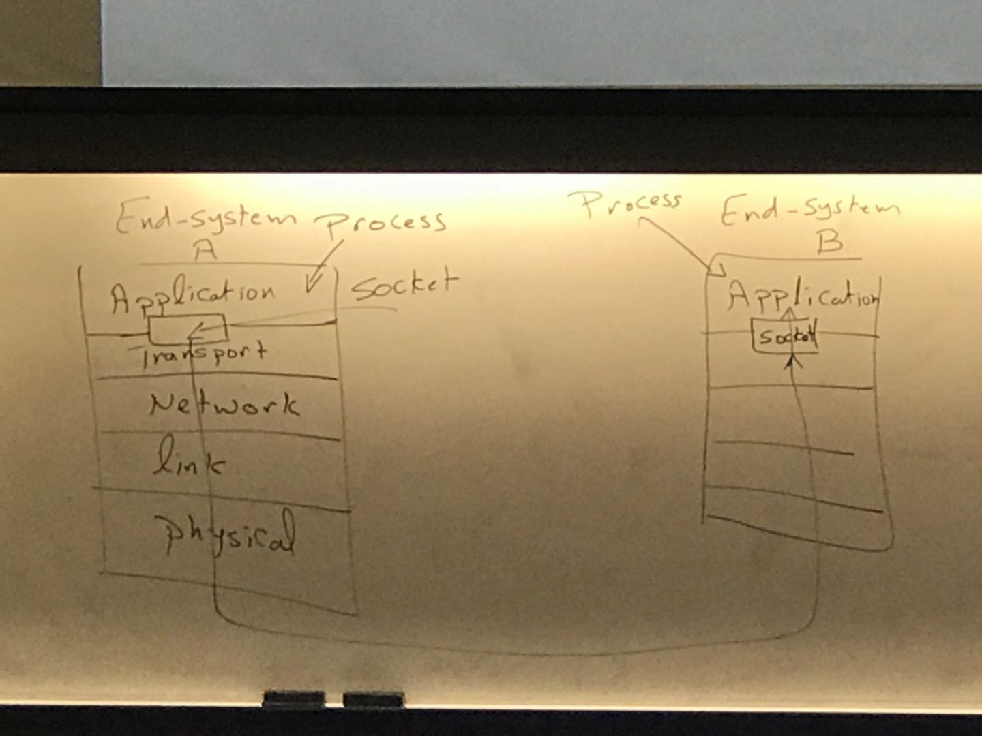

SSL: Secure secret layer

2.2 Web and HTTP

-network application needs to be implemented on end systems but not on network cores (routers or switches.)

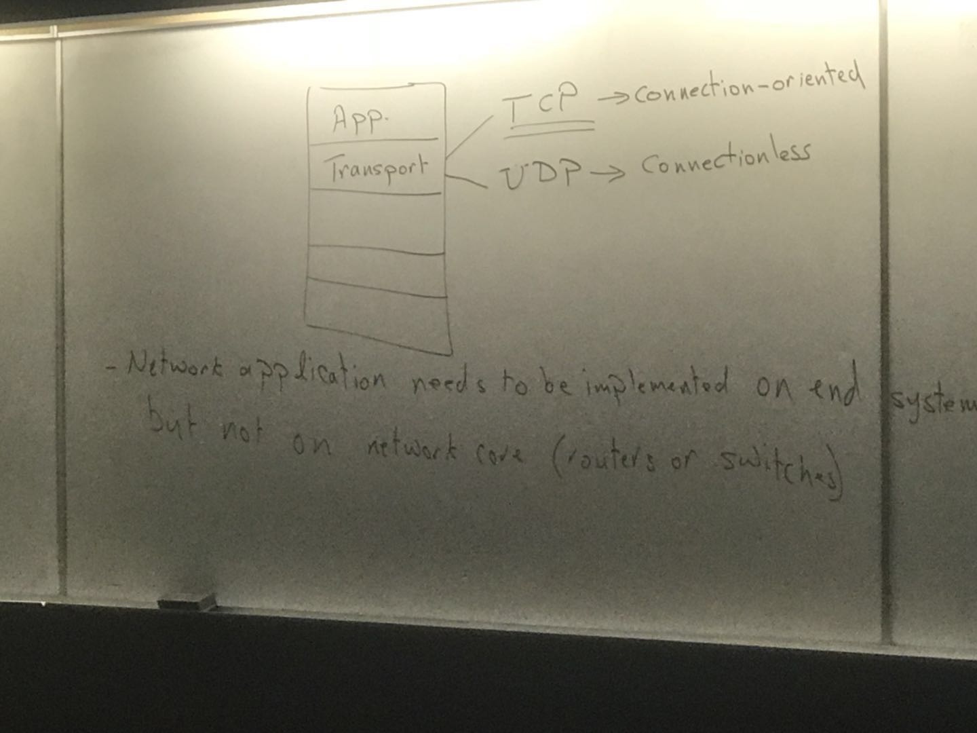

Network app architecture

1. Client server
2. P2P

HTTP – hyper text transfer protocol

It is used for web systems

Architecture of HTTP: Client-server

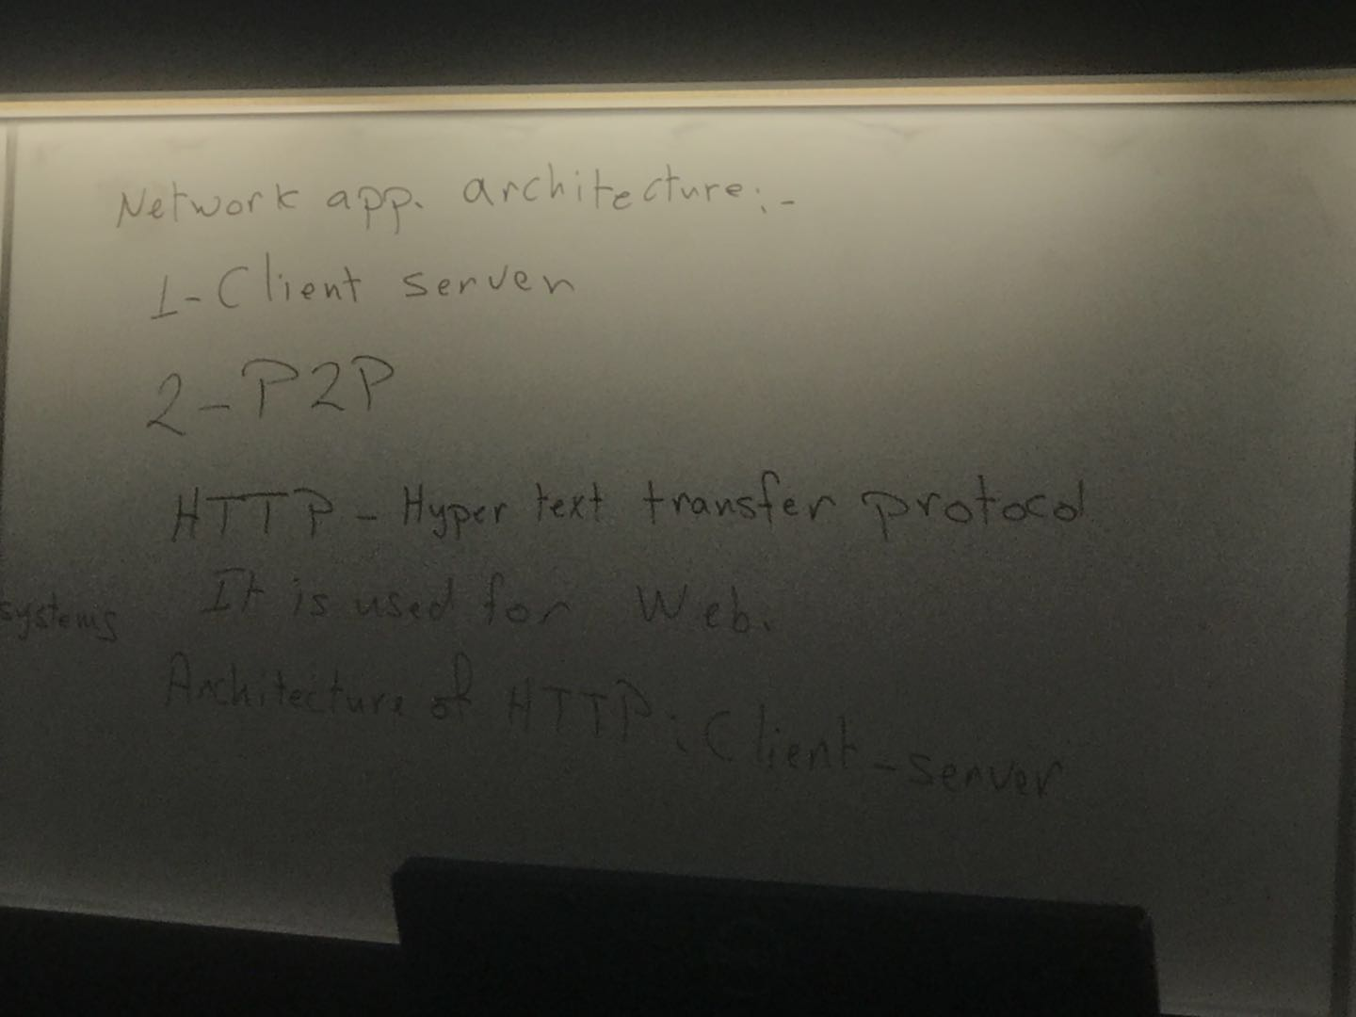

In pipelining, an end-system initiates requests for multiple objects without waiting to receive an object after the other.

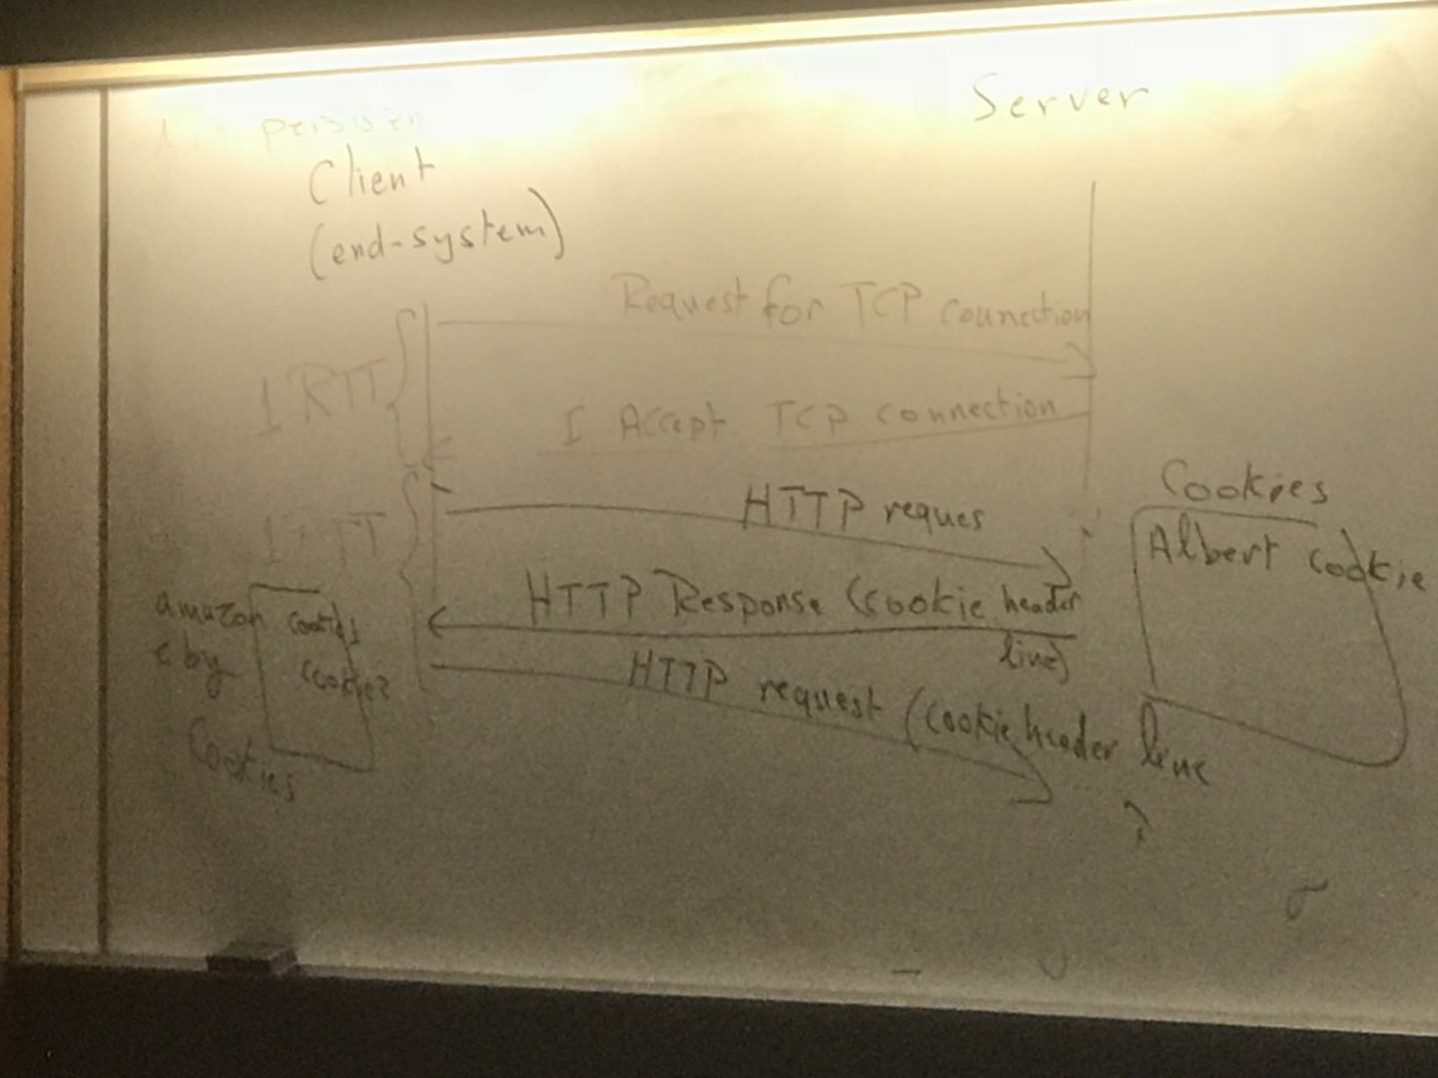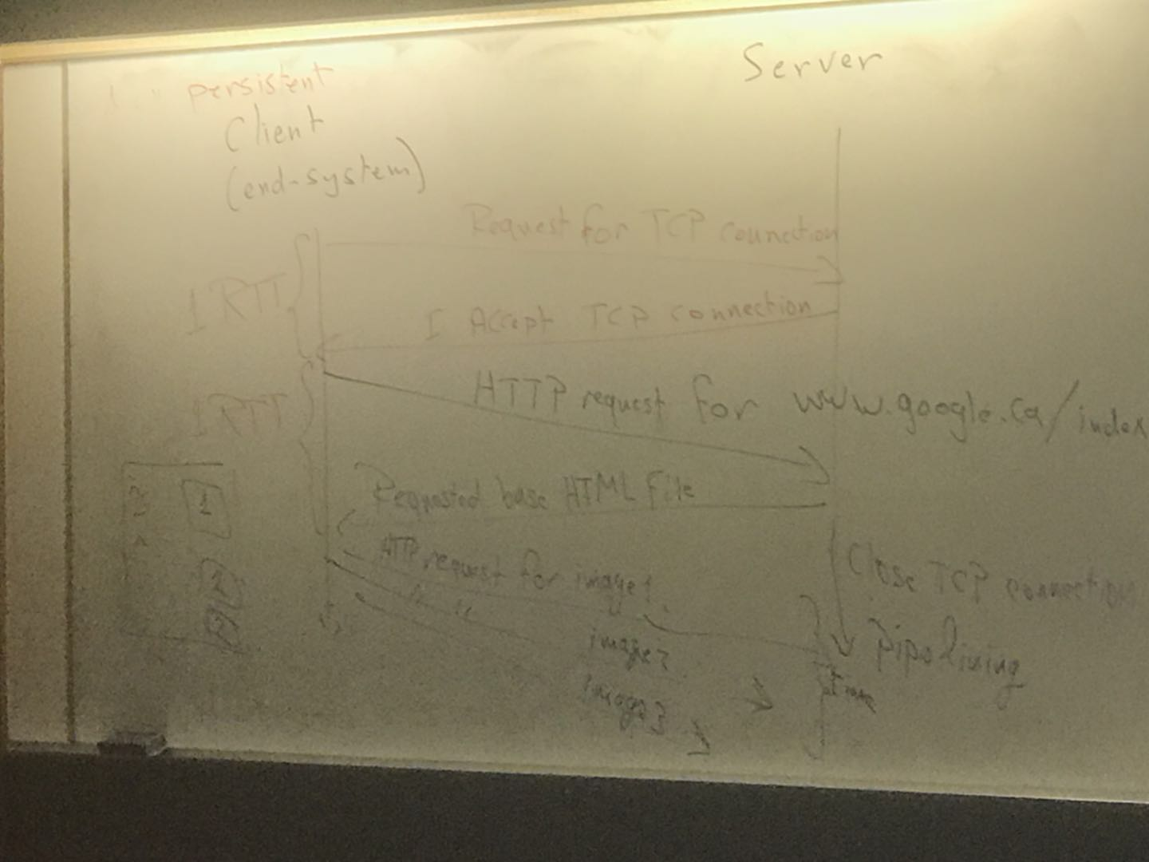

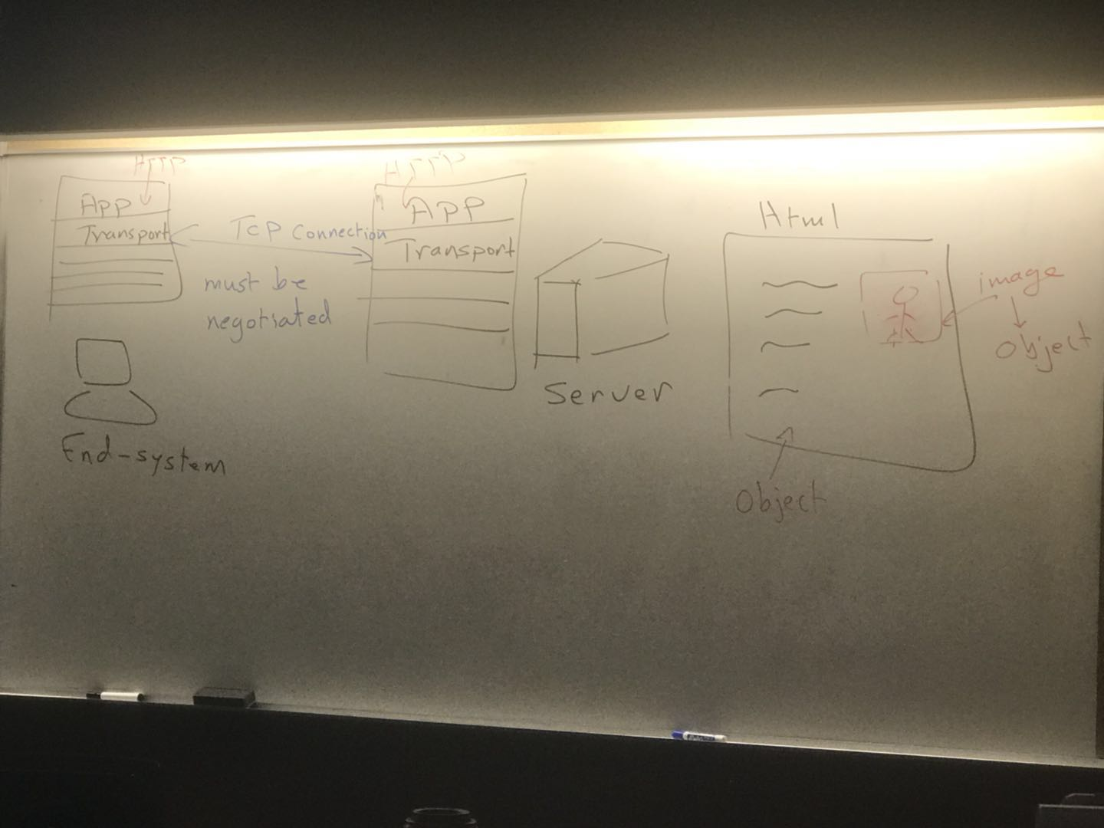

RTT-Round Trip time

A web cache(or proxy) is a network entity that handles the http requests on behalf of the web server if they have the request resources if not, the forward the http request to the web server.

HTTP 2 types

1. Persistent , one TCP connection for all objects
2. Non- persistent, one TCP connection per objects

Slide 2-39

LAN utilization = 1.5Mbps / 1G bps = 0.15%

Access link utilization = 1.5Mbps / 1.54 Mbps = 99%

Conditional get

DNS

Internet identifies network entities by their IP address

192.169.129.147 => [www.yahoo.com](http://www.yahoo.com)

DNS take care of translating URL to IP address

-DNS is an application layer protocol that allows hosts to communicate with name servers to translate hosts names to IP addresses.

-DNS use UDP as a transport protocol on port 53

For example, amazon webserver

Relay-1-east-west.amazon.ca (canonical form) alias=> [www.amazon.ca](http://www.amazon.ca)

Facebook servers

201.127.31.8

241.168.35.10

245.170.45.11

distributing the load on all the servers by rotating the IP address.

DNS: caching, updating records

TTL -> time to live

DNS -> distributed database:

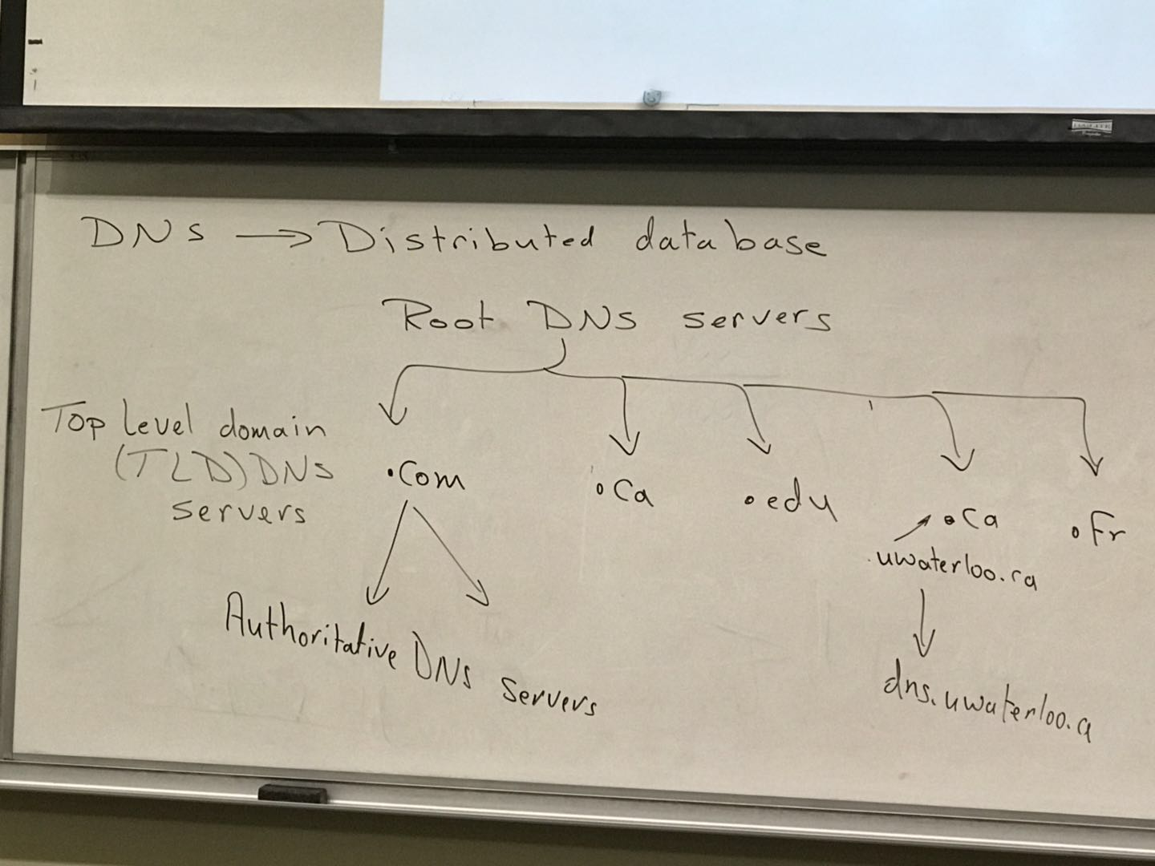

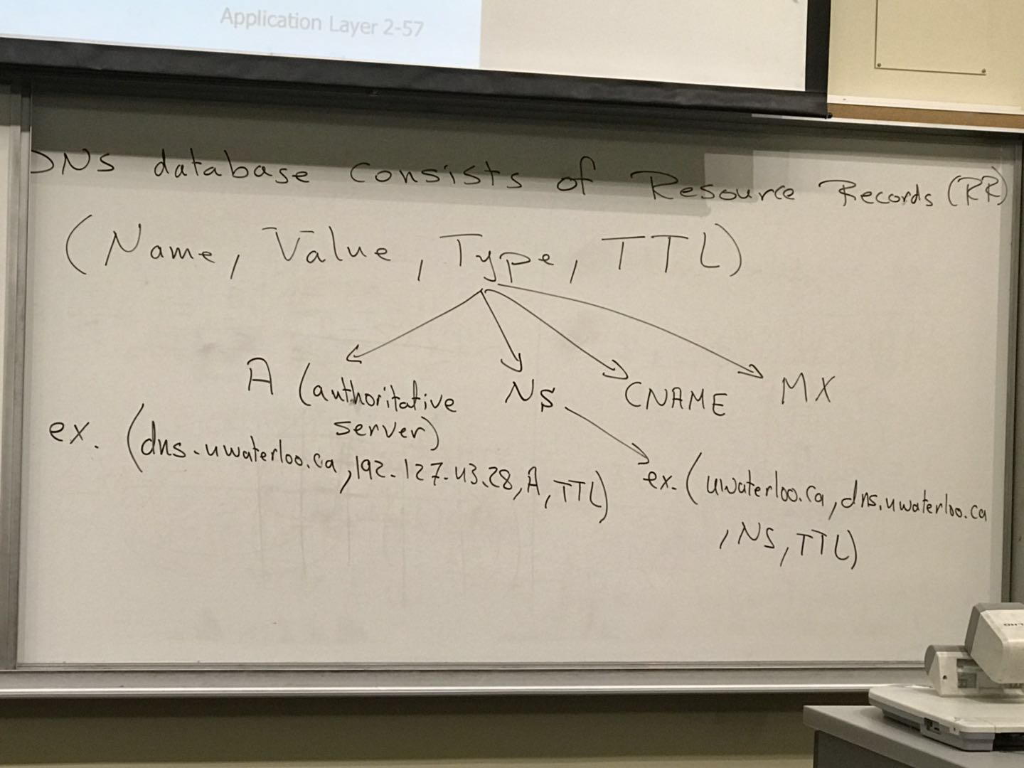

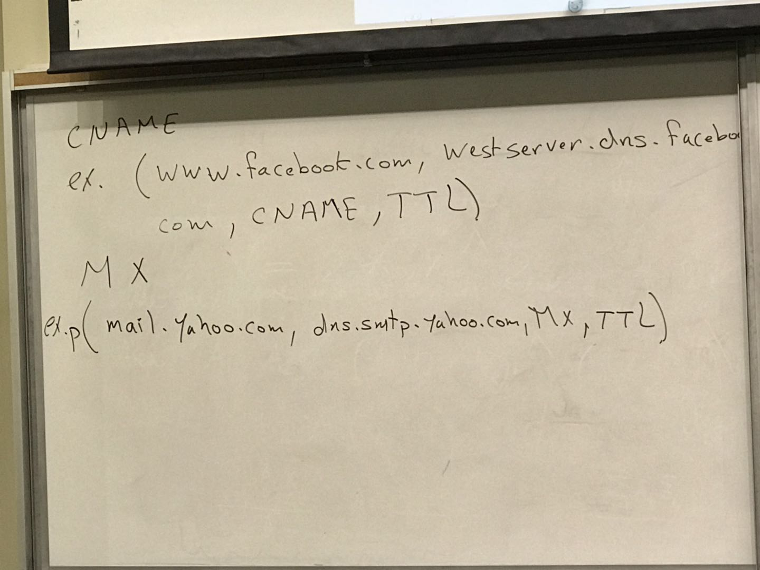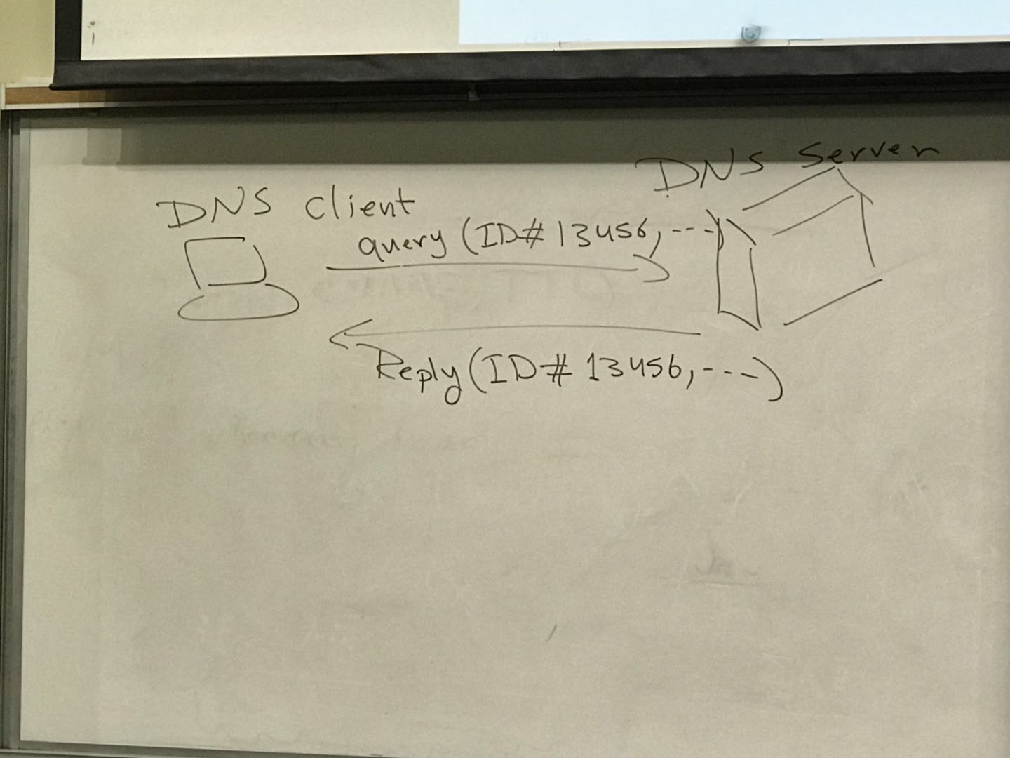

Chapter 2 Summary:  
A network application will be running on end-systems.